Here's a step-by-step guide to setting up your developer environment based on the requirements you've specified:

**1. Install Windows 11**

* Go to the [Windows 11 download page](https://www.microsoft.com/software-download/windows11).
* Follow the instructions to download and install Windows 11 on your machine.

**2. Install Visual Studio Code**

* Visit the [Visual Studio Code download page](https://code.visualstudio.com/Download).
* Download the installer suitable for Windows 11.
* Run the installer and follow the on-screen instructions to install Visual Studio Code.

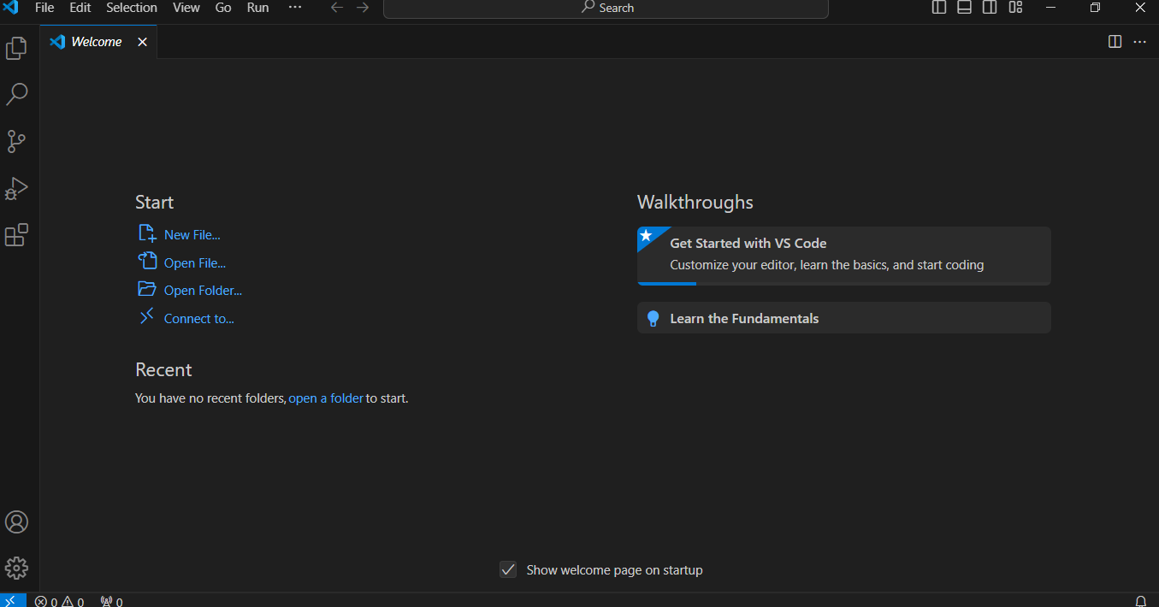

**3. Set Up Git and GitHub**

* Download Git from <https://git-scm.com/>.
* Run the installer and follow the installation instructions.
* After installation, open Git Bash (or use Command Prompt) and configure Git with your name and email:

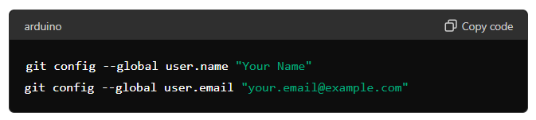 "y

* Create a GitHub account at <https://github.com/> if you haven't already.
* Initialize a Git repository for your project:

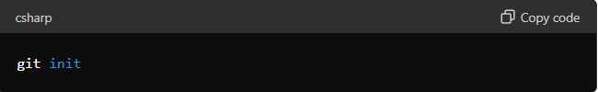

* Make your first commit:

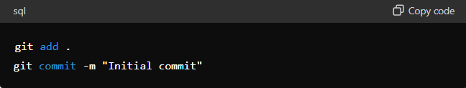

**4. Install Python**

* Download Python from <https://www.python.org/downloads/>.
* During installation, make sure to check the option "Add Python to PATH".
* Follow the installation wizard to complete the installation.

**5. Install MySQL**

* Download MySQL from <https://dev.mysql.com/downloads/windows/installer/5.7.html>.
* Run the installer and follow the installation instructions.
* Set up MySQL with the desired configuration (password, port, etc.).

**6. Install Pip (Python Package Manager)**

* Pip usually comes installed with Python. To upgrade pip, run:

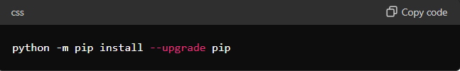

**7. Configure Virtualization (Optional)**

* Install Docker from https://www.docker.com/products/docker-desktop if you want to use containerized environments.

**8. Explore Visual Studio Code Extensions**

* Open Visual Studio Code.
* Explore and install extensions that suit your programming needs (e.g., Python, Git integration, MySQL, Docker).

**9. Document Your Setup**

* Create a document (e.g., README.md) where you outline the steps you've taken to set up your developer environment.
* Include configurations, installations, customizations, and any troubleshooting steps.
* This document will serve as a reference for future setups or team members.

By following these steps, I was able to have a fully functional developer environment

Top of Form